SIMATS ENGINEERING
ASSESSMENT TOOL 1

COURSE NAME: Database Management Systems
COURSE CODE: CSA05

COURSE OUTCOME COVERED

CO3: Analyze relational databases using functional dependencies, normalization (1NF to 5NF), and key constraints to identify redundancy and ensure data integrity. (BL2, BL3)

Activity Tool : Experiments (High)
Assessment Tool Weightage: 40%

Code of Conduct:

I T.MOHAN REDDY (192525118)(Name / Reg No) certify that this submission is my original work and that I have adhered to the guidelines specified for this assessment.
I understand that any violation of academic integrity rules will result in disciplinary action.

Signature of the student: T.MOHAN REDDY (192525118)

Q1. For the relation STUDENT_COURSE(SID, SName, CID, CName, Instructor, Grade), identify all functional dependencies and determine the candidate keys.

Definition:
A Functional Dependency (FD) is a relationship between attributes where one attribute (or a set of attributes) uniquely determines another attribute.
It is represented as:
X → Y
where X is the determinant and Y is the dependent attribute.

Given Relation:
STUDENT_COURSE(SID, SName, CID, CName, Instructor, Grade)
Attributes:
- SID – Student ID
- SName – Student Name
- CID – Course ID
- CName – Course Name
- Instructor – Course Instructor
- Grade – Student Grade

Step 1: Identify Functional Dependencies
From the given relation, the functional dependencies are:
- SID → SName o Each Student ID uniquely determines the Student Name.
- CID → CName, Instructor o Each Course ID uniquely determines the Course Name and Instructor.
- SID, CID → Grade o A student's grade depends on both the Student ID and the Course ID.
Therefore,
FD1: SID → SName
FD2: CID → CName, Instructor
FD3: (SID, CID) → Grade

Step 2: Determine Candidate Key
Compute the closure of (SID, CID):
(SID, CID)+
= {SID, CID} Using FD1:
→ SName
Using FD2: → CName, Instructor Using FD3:
→ Grade
Therefore,
(SID, CID)+
= {SID, SName, CID, CName, Instructor, Grade}
Since it determines all attributes, (SID, CID) is a Candidate Key.
Neither SID nor CID alone determines all attributes, so they are not candidate keys.

Prime and Non-Prime Attributes:
Prime Attributes:
- SID
- CID
Non-Prime Attributes:
- SName
- CName
- Instructor
- Grade

Final Answer:
Functional Dependencies
- SID → SName
- CID → CName, Instructor
- (SID, CID) → Grade Candidate Key:(SID, CID)
Super Key:Any attribute set containing (SID, CID) is a Super Key.

Examples:
- (SID, CID)
- (SID, CID, Grade)
- (SID, CID, Instructor)
Conclusion:
The relation contains three functional dependencies. The candidate key is (SID, CID) because together they uniquely determine all other attributes in the relation.
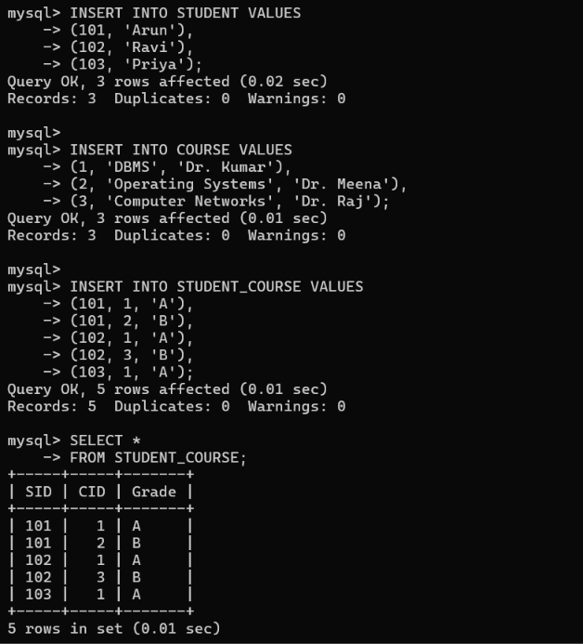
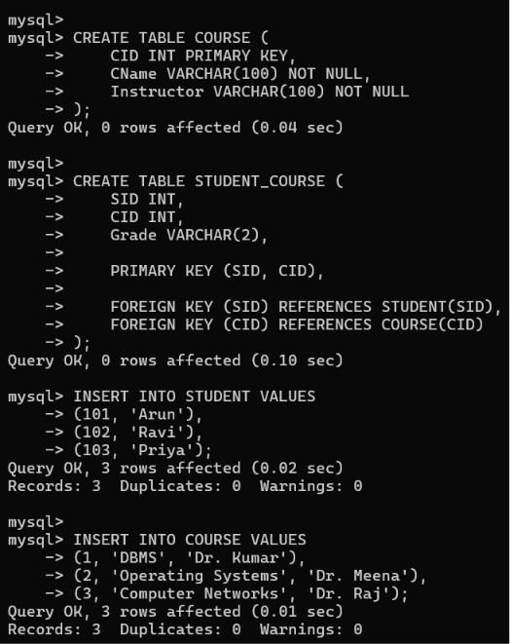

Q2. Demonstrate the process of converting an unnormalized relation into 1NF with step-bystep justification and an example.
Definition:
An Unnormalized Form (UNF) is a relation that contains repeating groups or multivalued attributes. The data is not organized properly, leading to redundancy and inconsistency.
First Normal Form (1NF) states that:
- Every attribute must contain only atomic (single) values.
- There should be no repeating groups or multivalued attributes.
- Each row must be uniquely identifiable using a primary key.

Given Example (UNF)
Consider the following STUDENT relation:
SID | Student Name | Courses
S101 | Aisha | DBMS, Python
S102 | Rahul | Java, C++, SQL
S103 | Priya | DBMS
Here, the Courses attribute contains multiple values in a single cell. Therefore, the relation is in UNF.

Step 1: Identify the Repeating Group The repeating group is:
Courses = {DBMS, Python, Java, C++, SQL}
Since one attribute stores multiple values, it violates the rule of 1NF.

Step 2: Remove the Repeating Group
Create a separate row for each course taken by a student.

Step 3: Convert into 1NF
The relation after conversion is:
SID | Student Name | Course
S101 | Aisha | DBMS
S101 | Aisha | Python
S102 | Rahul | Java
S102 | Rahul | C++
S102 | Rahul | SQL
S103 | Priya | DBMS
Now, each cell contains only one value, satisfying the requirements of 1NF.

Justification:
The converted relation satisfies all the rules of First Normal Form because:
- Every attribute contains atomic (single) values.
- Repeating groups are eliminated.
- Each record represents one student enrolled in one course.
- The relation can be uniquely identified using the composite key (SID, Course).

Advantages of Converting to 1NF:
- Eliminates repeating groups.
- Improves data consistency.
- Simplifies searching and updating records.
- Provides the foundation for higher normal forms such as 2NF and 3NF.

Final Answer
UNF Relation:
SID | Student Name | Courses
S101 | Aisha | DBMS, Python
S102 | Rahul | Java, C++, SQL
S103 | Priya | DBMS

1NF Relation:
SID | Student Name | Course
S101 | Aisha | DBMS
S101 | Aisha | Python
S102 | Rahul | Java
S102 | Rahul | C++
S102 | Rahul | SQL
S103 | Priya | DBMS
Primary Key: (SID, Course)

Conclusion:
The given unnormalized relation was converted into First Normal Form (1NF) by removing the repeating group and ensuring that every attribute contains a single, atomic value. The resulting relation is well-structured, free from multivalued attributes, and ready for further normalization into 2NF.
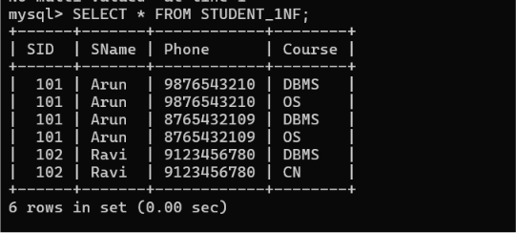
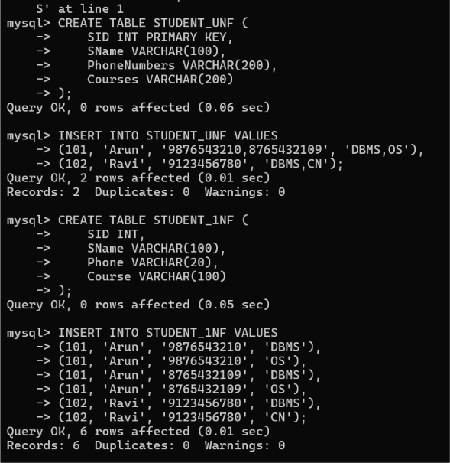

Q3. Given the relation R(A, B, C, D, E) with the following functional dependencies:
- A → BC
- BC → D
- D → E
Decompose the relation into Second Normal Form (2NF) by removing partial dependencies.

Definition of Second Normal Form (2NF):
A relation is said to be in Second Normal Form (2NF) if:
- It is already in First Normal Form (1NF).
- Every non-prime attribute is fully functionally dependent on the entire candidate key.
- There are no partial dependencies.
Step 1: Given Relation
R(A, B, C, D, E)
Functional Dependencies:
- A → BC
- BC → D
- D → E

Step 2: Find the Candidate Key Find the closure of A.
A⁺ = {A}
Using A → BC
A⁺ = {A, B, C}
Using BC → D
A⁺ = {A, B, C, D}
Using D → E
A⁺ = {A, B, C, D, E}
Since A determines all attributes, the candidate key is A.

Step 3: Check for Partial Dependency
A partial dependency occurs only when the candidate key consists of more than one attribute (composite key).
Here, the candidate key is A, which is a single attribute.
Therefore, there is no partial dependency.

Step 4: 2NF Decomposition
Since there is no partial dependency, no decomposition is required.
The relation remains:
R(A, B, C, D, E)

Final Answer Candidate Key: A
Functional Dependencies: • A → BC • BC → D
• D → E

Partial Dependency: None
2NF Relation: R(A, B, C, D, E)

Conclusion:
The given relation is already in Second Normal Form (2NF) because the candidate key is a single attribute (A), and hence no partial dependency exists. Therefore, no decomposition is necessary.

Q4. Given the relation EMPLOYEE(EmpID, EmpName, DeptID, DeptName, ManagerID), perform Third Normal Form (3NF) decomposition by removing transitive dependencies.

Definition of Third Normal Form (3NF):
A relation is said to be in Third Normal Form (3NF) if:
- It is already in Second Normal Form (2NF).
- There are no transitive dependencies.
- Every non-prime attribute depends only on the candidate key and not on another non-prime attribute.

Step 1: Given Relation
EMPLOYEE(EmpID, EmpName, DeptID, DeptName, ManagerID)
Functional Dependencies
- EmpID → EmpName, DeptID
- DeptID → DeptName, ManagerID

Step 2: Find the Candidate Key The closure of EmpID is:
EmpID⁺ = {EmpID}
Using EmpID → EmpName, DeptID
EmpID⁺ = {EmpID, EmpName, DeptID}
Using DeptID → DeptName, ManagerID
EmpID⁺ = {EmpID, EmpName, DeptID, DeptName, ManagerID}
Since EmpID determines all attributes,
Candidate Key = EmpID

Step 3: Identify the Transitive Dependency From the functional dependencies:
- EmpID → DeptID
- DeptID → DeptName, ManagerID
Therefore,
EmpID → DeptName, ManagerID
This is a transitive dependency because DeptName and ManagerID depend on DeptID, not directly on EmpID.

Step 4: Perform 3NF Decomposition
Split the relation into two relations.
Relation 1: EMPLOYEE
EmpID | EmpName | DeptID
E101 | Aisha | D01
E102 | Rahul | D02
Primary Key: EmpID

Relation 2: DEPARTMENT
DeptID | DeptName | ManagerID
D01 | Computer Science | M101
D02 | Information Technology | M102
Primary Key: DeptID

Advantages of 3NF:
- Removes transitive dependency.
- Eliminates update anomalies.
- Reduces data redundancy.
- Improves data consistency.
- Makes database maintenance easier.

Final Answer
Original Relation
EMPLOYEE(EmpID, EmpName, DeptID, DeptName, ManagerID)
Functional Dependencies
- EmpID → EmpName, DeptID
- DeptID → DeptName, ManagerID
Candidate Key
EmpID
3NF Decomposition
EMPLOYEE(EmpID, EmpName, DeptID)
DEPARTMENT(DeptID, DeptName, ManagerID)

Conclusion:
The original relation contained a transitive dependency because DeptName and ManagerID depended on DeptID, which in turn depended on EmpID. By decomposing the relation into EMPLOYEE and DEPARTMENT, the database satisfies Third Normal Form (3NF), reducing redundancy and improving data integrity.

Q5. Given the relation R(A, B, C, D) with the following functional dependencies:
- AB → C
- C → D
- D → A
Check whether the relation is in Boyce-Codd Normal Form (BCNF). If not, decompose it into BCNF.

Definition of BCNF:
A relation is in Boyce-Codd Normal Form (BCNF) if:
- For every non-trivial functional dependency X → Y, X must be a super key.
BCNF is a stronger version of Third Normal Form (3NF) and eliminates redundancy caused by functional dependencies.

Step 1: Given Relation
R(A, B, C, D)
Functional Dependencies:
- AB → C
- C → D
- D → A
Step 2: Find the Candidate Key Find the closure of AB.
(AB)⁺ = {A, B} Using AB → C
= {A, B, C}
Using C → D
= {A, B, C, D}
Therefore,
(AB)⁺ = {A, B, C, D}
Hence,
Candidate Key = AB
Step 3: Check BCNF Condition
FD1: AB → C
- AB is a candidate key (super key).
- Therefore, this dependency satisfies BCNF.

FD2: C → D
- C is not a super key.
- Therefore, this violates BCNF.

FD3: D → A
- D is not a super key.
- Therefore, this also violates BCNF.
Hence, the relation is not in BCNF.

Step 4: BCNF Decomposition
Since C → D violates BCNF, decompose the relation into:
Relation 1
R₁(C, D)
Functional Dependency:
C → D
Candidate Key: C
This relation is in BCNF.

Relation 2:
R₂(A, B, C)
Functional Dependency:
AB → C
Candidate Key: AB
This relation is also in BCNF.

Final BCNF Relations:
R₁(C, D)
C | D
C1 | D1
C2 | D2
Primary Key: C

R₂(A, B, C)
A | B | C
A1 | B1 | C1
A2 | B2 | C2
Primary Key: AB

Advantages of BCNF:
- Eliminates redundancy.
- Removes anomalies.
- Ensures every determinant is a super key.
- Improves database consistency.
- Makes the database more efficient.

Final Answer Candidate Key: AB
BCNF Violations:
- C → D
- D → A
BCNF Decomposition:
- R₁(C, D)
- R₂(A, B, C)

Conclusion:
The relation R(A, B, C, D) is not in BCNF because the functional dependencies C → D and D →
A have determinants that are not super keys. By decomposing the relation into R₁(C, D) and R₂(A, B, C), all BCNF conditions are satisfied, resulting in a well-structured database with reduced redundancy and improved data integrity.

Q6. Verify whether the given decomposition is lossless using the Chase (Tabular) Algorithm.

Definition of Lossless Join:
A Lossless Join Decomposition ensures that when the decomposed relations are joined back using a natural join, the original relation is obtained without any loss of information.
The Chase (Tabular) Algorithm is a method used to verify whether a decomposition is lossless.

Given Relation:
Let the relation be:
R(A, B, C)
Functional Dependency:
A → B
The relation is decomposed into:
- R₁(A, B)
- R₂(A, C)
We need to verify whether this decomposition is lossless.
Step 1: Construct the Chase Table
Relation | A | B | C
R₁(A,B) | a₁ | b₁ | c₁
R₂(A,C) | a₁ | b₂ | c₂
Since A is common to both relations, assign the same symbol (a₁) in both rows.
Step 2: Apply the Functional Dependency Functional Dependency: A → B
Since both rows have the same value for A (a₁), the values of B must also be the same.
Update the table:
Relation | A | B | C
R₁(A,B) | a₁ | b₁ | c₁
R₂(A,C) | a₁ | b₁ | c₂
The value b₂ is replaced by b₁.
Step 3: Check the Result
After applying the functional dependency:
- The common attribute A matches.
- The dependent attribute B also becomes identical.
- One row can now represent the original relation.
Hence, the decomposition is Lossless.
Result:
Decomposition:
- R₁(A, B)
- R₂(A, C)
Functional Dependency:
- A → B
Conclusion:
The decomposition is Lossless Join because the original relation can be reconstructed without any loss of information.

Advantages of Lossless Join:
- Prevents loss of data.
- Preserves data integrity.
- Ensures accurate reconstruction of the original relation.
- Reduces redundancy.
- Improves database consistency.

Final Answer
Given Relation:
R(A, B, C)
Functional Dependency:
A → B
Decomposition:
- R₁(A, B)
- R₂(A, C)
Using the Chase Algorithm, the common attribute A determines B, making the values consistent across both relations. Therefore, the decomposition is Lossless Join.

Conclusion:
The decomposition satisfies the Lossless Join Property because joining R₁(A, B) and R₂(A, C) recreates the original relation without introducing spurious tuples or losing any information.

Q7. Given the relation TEACHER(TID, Subject, Hobby), identify the Multivalued
Dependencies (MVDs) and decompose the relation into Fourth Normal Form (4NF).

Definition of Fourth Normal Form (4NF):
A relation is in Fourth Normal Form (4NF) if:
- It is already in Boyce-Codd Normal Form (BCNF).
- It contains no non-trivial Multivalued Dependencies (MVDs).
A Multivalued Dependency (MVD) occurs when one attribute determines multiple independent values of another attribute.
It is denoted as:
A ↠ B
Step 1: Given Relation TEACHER(TID, Subject, Hobby) Where:
- TID – Teacher ID
- Subject – Subject taught
- Hobby – Teacher's hobby
Step 2: Identify the Multivalued Dependencies Assume:
- A teacher can teach multiple subjects.
- A teacher can have multiple hobbies.
- Subjects and hobbies are independent of each other.
Therefore, the Multivalued Dependencies are:
- TID ↠ Subject
- TID ↠ Hobby
These MVDs cause data redundancy.
Step 3: Example of the Relation
TID | Subject | Hobby
T101 | DBMS | Reading
T101 | DBMS | Painting
T101 | Java | Reading
T101 | Java | Painting
Here, every subject is repeated with every hobby, creating unnecessary duplication.

Step 4: Decompose into 4NF
Split the relation into two separate relations.
Relation 1: TEACHER_SUBJECT
TID | Subject
T101 | DBMS
T101 | Java
Primary Key: (TID, Subject)

Relation 2: TEACHER_HOBBY
TID | Hobby
T101 | Reading
T101 | Painting
Primary Key: (TID, Hobby)

Advantages of 4NF:
- Removes multivalued dependencies.
- Eliminates unnecessary data duplication.
- Reduces storage space.
- Prevents update anomalies.
- Improves database consistency and integrity.

Final Answer:
Multivalued Dependencies
- TID ↠ Subject
- TID ↠ Hobby
4NF Decomposition
TEACHER_SUBJECT(TID, Subject)
TEACHER_HOBBY(TID, Hobby)

Conclusion:
The original relation contained multivalued dependencies, causing redundancy because each subject was paired with every hobby. By decomposing it into TEACHER_SUBJECT and TEACHER_HOBBY, the relation satisfies Fourth Normal Form (4NF), eliminating redundancy and improving database efficiency.

Q8. Explain how Join Dependencies cause redundancy and decompose the given relation into Fifth Normal Form (5NF).

Definition of Fifth Normal Form (5NF):
A relation is in Fifth Normal Form (5NF), also known as Projection-Join Normal Form (PJNF), if:
- It is already in Fourth Normal Form (4NF).
- Every Join Dependency (JD) is implied by the candidate keys.
- The relation cannot be further decomposed without losing information.
A Join Dependency exists when a relation can be reconstructed by joining three or more smaller relations without any loss of data.
Step 1: Given Relation Consider the relation:
SUPPLIER_PART_PROJECT(Supplier, Part, Project) Where:
- Supplier supplies Parts
- Parts are used in Projects
- Suppliers supply Parts to Projects

Step 2: Example of the Relation
Supplier | Part | Project
S1 | P1 | J1
S1 | P2 | J1
S2 | P1 | J2
This relation may contain redundancy because the same supplier, part, and project information is repeated.
Step 3: Decompose into 5NF
The relation is decomposed into three smaller relations:
Relation 1: SUPPLIER_PART
Supplier | Part
S1 | P1
S1 | P2
S2 | P1

Relation 2: PART_PROJECT
Part | Project
P1 | J1
P2 | J1
P1 | J2

Relation 3: SUPPLIER_PROJECT
Supplier | Project
S1 | J1
S2 | J2
Step 4: Verify the Join
Joining the three relations:
- SUPPLIER_PART
- PART_PROJECT
- SUPPLIER_PROJECT
reconstructs the original relation SUPPLIER_PART_PROJECT without any loss of information.
Hence, the decomposition is lossless and satisfies 5NF.
Advantages of 5NF:
- Eliminates join dependency redundancy.
- Removes unnecessary duplicate data.
- Prevents insertion, update, and deletion anomalies.
- Improves database consistency.
- Ensures efficient database design.
Final Answer:
Original Relation
SUPPLIER_PART_PROJECT(Supplier, Part, Project)
5NF Decomposition:
- SUPPLIER_PART(Supplier, Part)
- PART_PROJECT(Part, Project)
- SUPPLIER_PROJECT(Supplier, Project)

The original relation contained join dependency, which caused redundancy. By decomposing it into SUPPLIER_PART, PART_PROJECT, and SUPPLIER_PROJECT, the database satisfies Fifth Normal Form (5NF). The original relation can be reconstructed by joining these three relations without any loss of information, ensuring a well-normalized and efficient database.

Q9. Given a poorly designed College Database Schema, identify the insertion, deletion, and update anomalies. Then normalize the relation up to Third Normal Form (3NF).

Definition of Normalization:
Normalization is the process of organizing data in a database to reduce redundancy and eliminate anomalies. It improves data consistency and integrity by dividing a large table into smaller related tables.
Given Relation:
COLLEGE(EmpID, EmpName, DeptID, DeptName, HOD)
EmpID | EmpName | DeptID | DeptName | HOD
E101 | Aisha | D01 | CSE | Dr. Kumar
E102 | Rahul | D01 | CSE | Dr. Kumar
E103 | Priya | D02 | IT | Dr. Meena

Step 1: Identify Functional Dependencies
- EmpID → EmpName, DeptID
- DeptID → DeptName, HOD Candidate Key: EmpID Step 2: Identify the Anomalies
1. Insertion Anomaly:
A new department cannot be inserted unless at least one employee is assigned to it.
Example: If a new department ECE is created but no employee has joined, its details cannot be stored.
- Update Anomaly:
If the HOD of the CSE department changes, the change must be updated in every row where DeptID = D01.
Failure to update all rows results in inconsistent data.
- Deletion Anomaly:
If employee E103 leaves the college and the record is deleted, the information about the IT department and its HOD is also lost.
Step 3: Normalize to 3NF

Relation 1: EMPLOYEE
EmpID | EmpName | DeptID
E101 | Aisha | D01
E102 | Rahul | D01
E103 | Priya | D02
Primary Key: EmpID
Relation 2: DEPARTMENT
DeptID | DeptName | HOD
D01 | CSE | Dr. Kumar
D02 | IT | Dr. Meena
Primary Key: DeptID
Advantages of 3NF:
  - Eliminates transitive dependency.
  - Removes insertion, update, and deletion anomalies.
  - Reduces data redundancy.
  - Improves data consistency.
  - Makes database maintenance easier.
Final Answer:
Original Relation:
COLLEGE(EmpID, EmpName, DeptID, DeptName, HOD)
Functional Dependencies:
  - EmpID → EmpName, DeptID
  - DeptID → DeptName, HOD
Anomalies:
  - Insertion Anomaly: Cannot insert a new department without an employee.
  - Update Anomaly: Updating the HOD requires changes in multiple rows.
  - Deletion Anomaly: Deleting the last employee of a department removes department details.
3NF Decomposition:
EMPLOYEE(EmpID, EmpName, DeptID)
DEPARTMENT(DeptID, DeptName, HOD)

The original relation suffered from insertion, update, and deletion anomalies due to transitive dependency. By decomposing it into EMPLOYEE and DEPARTMENT, the database is normalized to Third Normal Form (3NF). This removes redundancy, improves consistency, and ensures efficient data management.

Q10. Compute the Attribute Closure and Determine All Candidate Keys for the Given Functional Dependencies.

Definition of Attribute Closure:
The attribute closure of an attribute set X, denoted by X⁺, is the set of all attributes that can be functionally determined from X using the given functional dependencies.
Attribute closure is used to:
- Find candidate keys.
- Check functional dependencies.
- Verify normalization.
Given Relation:
R(A, B, C, D, E)
Functional Dependencies:
- A → BC
- BC → D
- D → E
Step 1: Compute the Attribute Closure of A
Initially,
A⁺ = {A}
Using A → BC
A⁺ = {A, B, C}
Using BC → D
A⁺ = {A, B, C, D}
Using D → E
A⁺ = {A, B, C, D, E}
Therefore,
A⁺ = {A, B, C, D, E}
Since the closure of A contains all the attributes in the relation, A is a Candidate Key.

Step 2: Check Other Attributes Closure of B:
B⁺ = {B}
No further attributes can be determined.
Hence, B is not a candidate key.
Closure of C:
C⁺ = {C}
No further attributes can be determined.
Hence, C is not a candidate key.
Closure of D:
D⁺ = {D}
Using D → E
D⁺ = {D, E}
It does not determine all attributes.
Hence, D is not a candidate key.
Closure of E:
E⁺ = {E}
No further attributes can be determined.
Hence, E is not a candidate key.
Step 3: Determine Candidate Keys
A candidate key is the smallest set of attributes that determines all attributes in the relation.
Since
A⁺ = {A, B, C, D, E} the only Candidate Key is:
A
Final Answer:
Attribute Closure:
- A⁺ = {A, B, C, D, E}
- B⁺ = {B}
- C⁺ = {C}
- D⁺ = {D, E}
- E⁺ = {E}
Candidate Key:
A

By computing the attribute closures using the given functional dependencies, we found that A determines all the attributes in the relation. Therefore, A is the only candidate key, while the other attributes cannot uniquely identify all the attributes in the relation.

